Task 2: Investigation of Hess’s Law
Purpose:
The purpose of this experiment is to test the concept of Hess’s Law through the use of calorimetry by determining the enthalpy of neutralization of sodium hydroxide and hydrochloric acid.

Materials:
- Electronic balance
- Styrofoam cup
- Water
- Thermometer
- Scoopula
- 100 mL graduated cylinder
- Solid sodium hydroxide
- Aqueous sodium hydroxide
- Aqueous hydrochloric acid

Data Table:
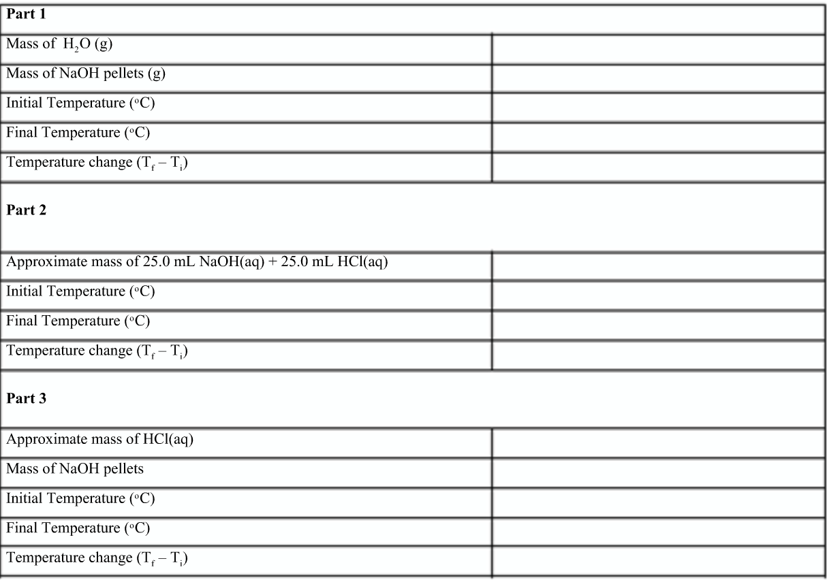
Parts 1 & 2 link: https://www.youtube.com/watch?v=8yFjgAtB8yg
Part 3 link: https://www.youtube.com/watch?v=ljenRO_BpN8

Calculations:
- For part 1, find the ∆H₁ of the reaction. Show your work.
NaOH_{(s)} -> NaOH_{(aq)}

- For part 2, find the ∆H₂ of the reaction. Show your work.
HCl_{(aq)} + NaOH_{(aq)} -> NaCl_{(aq)} + H₂O(l)

- For part 3, find the ∆H₃ of the overall reaction.
HCl_{(aq)} + NaOH_{(s)} -> NaCl_{(aq)} + H₂O(l)

- Find the ∆H₃ of the reaction. Next, compare this to the sum of parts 1 and 2 by using Hess’s law. Show all your work.

- Find the percent error of ∆H₁ and ∆H₂ in comparison to ∆H_{3.}

% error = $\frac{\left(∆H3\right)-[\left(∆H1\right)+\left(∆H2\right)]}{(∆H3)}$ x 100

Questions:

- Did you prove or disprove Hess’s law of heat Summation? Explain.
- How does this experiment illustrate the Law of Conservation of energy?
- Critique the calorimeter we used. What further improvements might help reduce your percent error?
- Conclusion?

